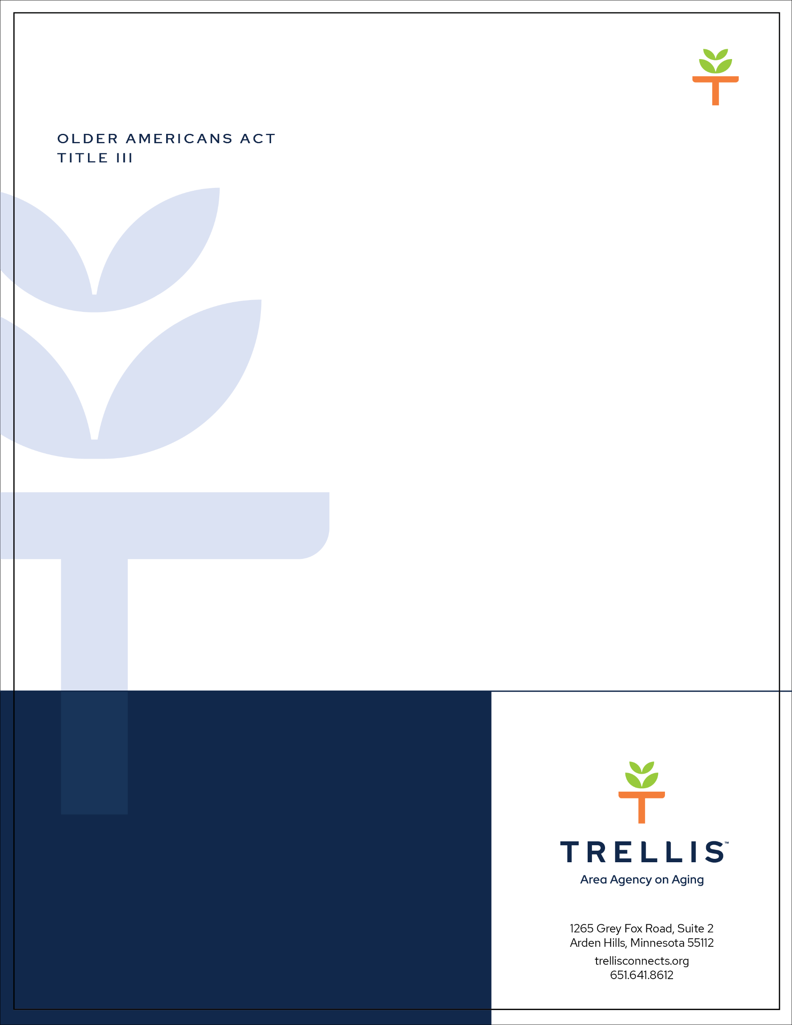
Applications due
June 23, 2023
2023 Title III-B
RFP Funding Application

For Supportive Services to Begin in 2024

Thank you for your interest in applying for Older Americans Act Title III-B Supportive Services funding to serve older adults across the Twin Cities metropolitan region. Please ensure that your application is complete with all required documentation before submission.

Trellis plans to implement a new online grant management system by early June. This funding application is available as a Word document and is intended to serve as a working document for you to develop your Title III-B Funding Application. Our goal is to have the III-B funding application submitted through our online grant management system. In the unlikely event that the grant management system is not ready by the submission deadline, this funding application will be submitted by email to title3@trellisconnects.org.

Note: if applying for multiple Title III funding sources, an application must be submitted for each funding type.

A completed application for Title III funding includes the following:

- Completed Organization Information Form
- Completed responses to the 13 narrative questions below.
- Required attachments:
  - Organizational chart
  - IRS Tax-Exempt letter, if a non-profit organization
  - Copy of 501(c)3 Incorporation, if a non-profit organization
  - Federally approved indirect cost rate (if applicable)
  - Insurance Certification (General Liability and Fidelity Bonding)
  - Latest total organization financial audit, if audited; latest annual financial statements if no audit has been performed
  - Budget and persons served (Excel version)
  - Subrecipient contract template (if applicable)

Applicant Organization Information:
Please include information about the organization applying for Title III funding.

Legal Name | Click or tap here to enter text.
Street Address | Click or tap here to enter text.
Mailing Address | Click or tap here to enter text.
City/State/Zip | Click or tap here to enter text.
Phone | Click or tap here to enter text.
Briefly describe the organization’s mission | Click or tap here to enter text.

Type of Organization (Select one):

☐ | Private Non-Profit
☐ | For-Profit
☐ | Governmental Unit
☐ | Tribal Entity

Number of years of operation: Click or tap here to enter text.

Is the organization or business certified as minority-owned by the Minnesota Office of State Procurement? Federal Reference: 45 CFR Part 75.330
☐ | Yes
☐ | No

Proposed Title III Key Personnel:
Please include contact information for staff responsible for managing the Title III award and program outcomes.

Chief Administrative Officer (e.g. Executive Director, CEO)
Name | Click or tap here to enter text.
Title | Click or tap here to enter text.
Address | Click or tap here to enter text.
City/State/Zip | Click or tap here to enter text.
Phone | Click or tap here to enter text.
Email | Click or tap here to enter text.
Project Manager responsible for managing award (Example: Submitting reports, completing budget).
Name | Click or tap here to enter text.
Title | Click or tap here to enter text.
Address | Click or tap here to enter text.
City/State/Zip | Click or tap here to enter text.
Phone | Click or tap here to enter text.
Email | Click or tap here to enter text.

Program Manager – Staff responsible for delivery services.
Name | Click or tap here to enter text.
Title | Click or tap here to enter text.
Address | Click or tap here to enter text.
City/State/Zip | Click or tap here to enter text.
Phone | Click or tap here to enter text.
Email | Click or tap here to enter text.

Financial Staff responsible for maintaining financial records related to federal funds.
Name | Click or tap here to enter text.
Title | Click or tap here to enter text.
Address
City/State/Zip | Click or tap here to enter text.
Phone | Click or tap here to enter text.
Fax | Click or tap here to enter text.
Email | Click or tap here to enter text.

Proposed Title III Service Area:
Please indicate counties to be served with Title III funding (check all that apply):

☐ | All of Anoka County
☐ | Part(s) of Anoka County
☐ | All of Carver County
☐ | Part(s) of Carver County
☐ | All of Dakota County
☐ | Part(s) of Dakota County
☐ | All of Hennepin County
☐ | Part(s) of Hennepin County
☐ | All of Ramsey County
☐ | Part(s) of Ramsey County
☐ | All of Scott County
☐ | Part(s) of Scott County
☐ | All of Washington County
☐ | Part(s) of Washington County
Financial Management Checklist
Select any of the following that represent your organization tracks revenue and expenses:

☐ | Cash System
☐ | Modified Accrual System
☐ | Accrual System

Organization financial management systems must include the following features to be eligible for federal Older Americans Act funds. Please indicate whether the following features are present. If features are not present, they must be present by the award start date, as required by the federal Uniform Guidance (45 CFR 75.301-365).

- Identification, in its accounts, of all Federal awards received and expended and the Federal programs under which they were received. Federal program and Federal award identification must include, as applicable, the CFDA title and number, Federal award identification number and year, name of the HHS awarding agency, and name of the pass-through entity, if any.
- Accurate, current, and complete disclosure of the financial results of each Federal award or program in accordance with the reporting requirements set forth in § 75.341 and 75.342.
- Records that identify adequately the source and application of funds for federally funded activities. These records must contain information pertaining to Federal awards, authorizations, obligations, unobligated balances, assets, expenditures, income and interest and be supported by source documentation.
- Effective control over, and accountability for, all funds, property, and other assets. The non-Federal entity must adequately safeguard all assets and assure that they are used solely for authorized purposes. See § 75.303.
- Comparison of expenditures with budget amounts for each Federal award.
- Written procedures to implement the requirements of § 75.305.
- Written procedures for determining the allowability of costs in accordance.
- Financial records, supporting documents, statistical records, and all other non-Federal entity records pertinent to a Federal award must be retained for a period of three years from the date of submission of the final expenditure report or, for Federal awards that are renewed quarterly or annually, from the date of the submission of the quarterly or annual financial report, respectively, as reported to the HHS awarding agency or pass-through entity in the case of a subrecipient. See § 75.361, 75.362, 75.363, 75.364, and 75.365 for additional information.

For additional information on required standards for financial management systems, see 45 C.F.R. 75.302.
III-B 2023 RFP Narrative Questions

You may use as many words as needed to fully answer each question below, though the narrative portion of this application is limited to 15 pages in the Word Document format. The maximum length of the full application is 20 pages.

- Please describe the proposed services to be provided and how they will be delivered (Feasibility).

  - How will these services impact the life of older adults in the communities being served (Impact)?

- Please describe your staffing and volunteer positions, including (Feasibility):
  - Positions included in the budget involved in the implementation of the service(s).

  - Subrecipient staffing information (if applicable).

  - Use of volunteers in the delivery of services.

- Please describe how program and staff organizational leadership reflect the communities being served (Leadership).

- How will your organization ensure you will be able to plan, implement, and deliver the proposed program and service units outlined in this RFP? (Feasibility)

- Please describe how your organization determines eligibility and prioritizes Title III-B services to those within the OAA target population. Descriptions should include (Feasibility):
- Intake, referral and service coordination.

- Determining eligibility and Target Population.

- Describe how the target population is included in program planning (Community Connection and Equity)

- Please describe your organization’s outreach efforts to recruit new program participants. (Community Connection)

- How will Title III-B funds be used to support these proposed services? (Feasibility)

  - Match is required for Supportive Services. Please list the sources of match and whether this match source will be available on January 1, 2024. Refer to 45 CFR 75.306 for more information.

- If your proposed rate is below or exceeds the recommended rate range, please explain why. (Feasibility)

- In the past six months has your organization hired new Senior Management, financial, and/or program personnel who would be working on the proposed programs in this RFP? (Feasibility)

- How will your organization ensure that reports are submitted on time, complete, and accurately? (Feasibility)

  - Which staff will be responsible for submitting reports?

- Has your organization received an award or contract to conduct programs similar to those proposed in this RFP? If yes, provide a list of those awards or contracts.

- Describe quality improvement activities to ensure that the proposed service(s) continue to meet the need of older adults in your community, and address historical inequities related to access of services. (Equity)

